**Program 14:Demonstrate Multilevel inheritance using any example hierarchy.**

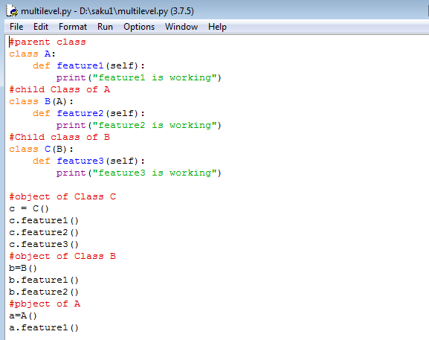

**Output:**

